Login to your teacher SuccessMaker Account
Username: FIRSTLAST
Password: LAST

Click on Courseware

Click on Math gear on the far right

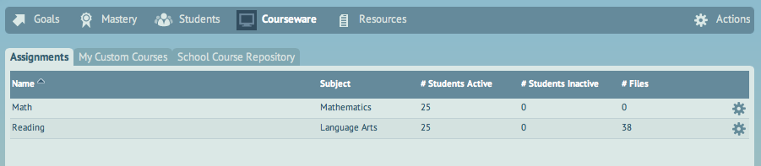

Click on One or more of my students

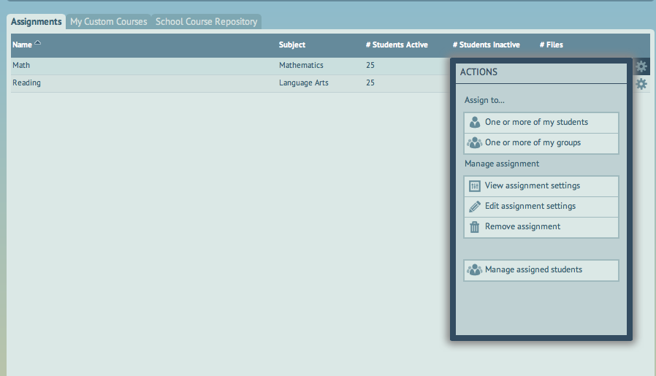

If there is curriculum to assign the student’s name will show up in the list. Select the student(s)

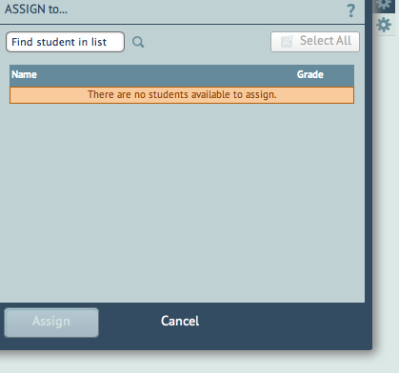

Click assign

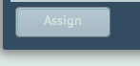

Repeat the steps for Reading, by clicking on the Reading gear

