Login to SuccessMaker teacher account
Username: FIRSTLAST
Password: LAST

Click Students in the toolbar at the top

Your roster will load up, then click Actions on the far right

Click +Add

Slick on Add new student
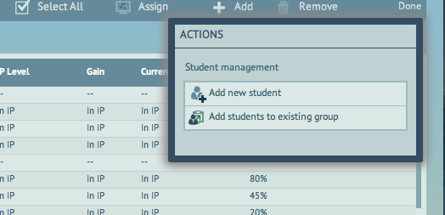

Fill in the information, Birthday is not needed. Student ID, Username, and Password are all the student’s number

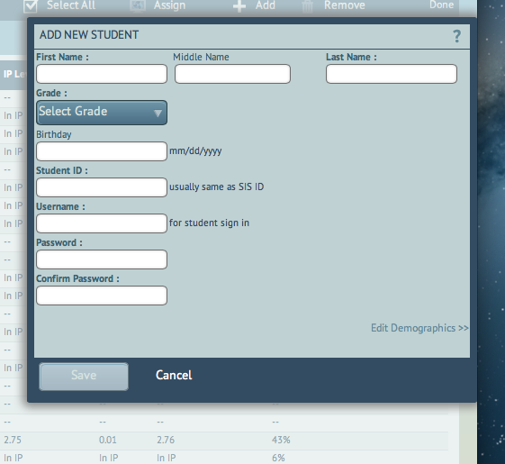

Click Save.

Click Done.

The student will now be in your roster.

