Adding Students from a School Roster
You can easily search the school roster for students to add to your class roster. The searching function helps you avoid adding duplicate students.
You can search for students by last name, first name, student ID, grade or any combination of that information. You can also perform a wildcard search by using an asterisk (*) as a placeholder for any unknown letters or numbers. For example, if you can't remember a student's last name, but you know the name starts with Sm, type Sm* in the Last name field. After clicking Search, all last names beginning with the letters Sm display. You can use the asterisk at the beginning or end of a character group.
To search for students to add from a school roster:
- On your top navigation menu, select Classes and then click Manage classes. The My Classes and Groups page appears.
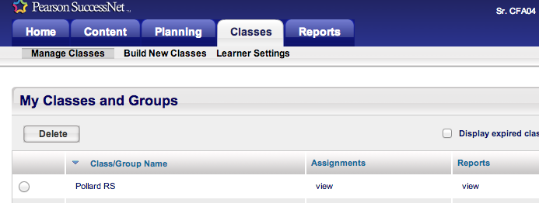
- In the Roster column, click View for the class roster you want to view. The Class/Group Roster page appears.
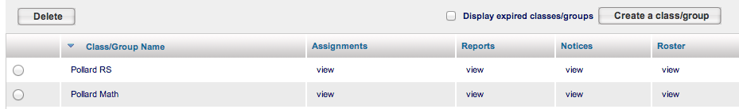

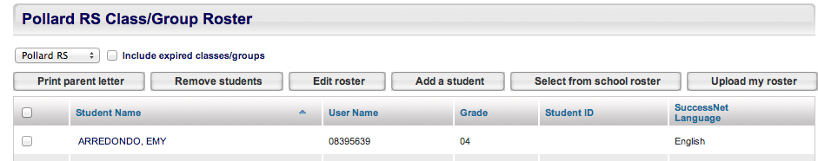

- Click Select from school roster. The Add Students from School Roster page appears.
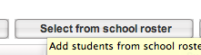
- Type or select any information about the student you want to add.
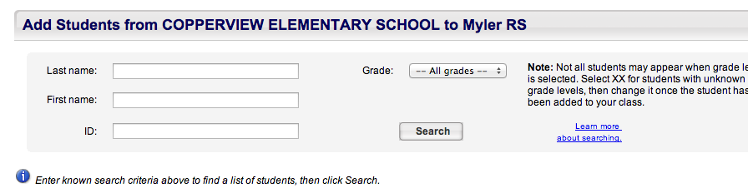
- Click Search.

Adding Students
After locating the student, you are ready to add the student from the school roster to your class roster.
To add students from a school roster:
- On the Add Students from School Roster page, select the student you are adding to the class roster.
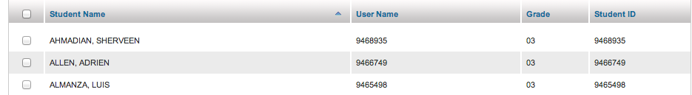

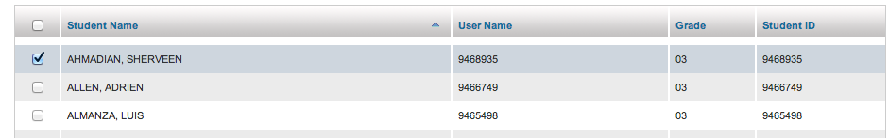

If you don’t see your student on the first page, check the next. Save before going to the next page.

- Scroll down to the bottom of the page and click Save. The selected students are now listed in your class roster.

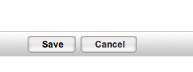

To perform a new search:
- Type or select your search criteria and click Search again.

If the student is not in the school roster, that is when you email sierra
*it may take up to 24 hours for the student to show up in the school roster once Sierra has uploaded the student.
Sierra.eastmond@canyonsdistrict.org
Please include the students name in your email

