Assigning a Test
Teachers use this function to assign a test to students. The assigned test will be listed in each student's To Do list.
To assign a test:
- On the top navigation menu, select Content and then click Tests. The Tests page appears.
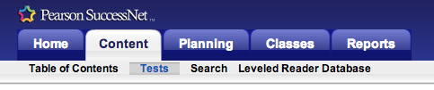
- Select a product and test type. For Envision math select Common Core, for Reading Street G, X select test type.
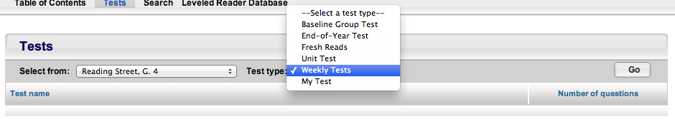
- Click Go to generate the test list.
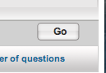
- Click a test name. The options menu appears.
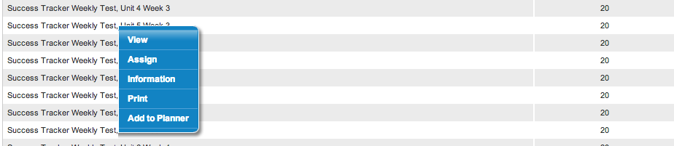

- Select Assign to assign the test. The Assign Test page appears.
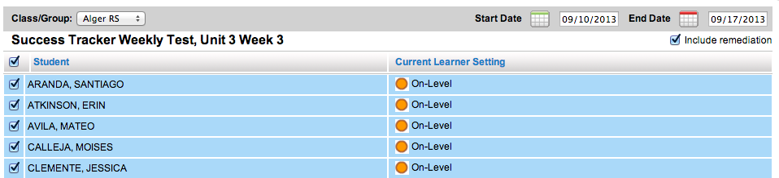
- In the Class/Group list, select the class or group to which you want to assign the test.
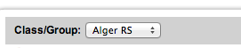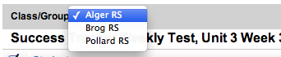
The Start Date and End Date fields show the start and end fate of the test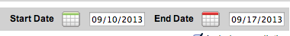
- Click the Start Date field. A small calendar appears. Pick a start date for the test.
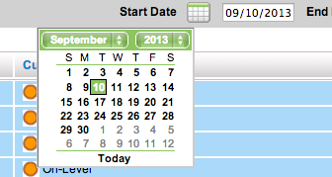

- Click the End Date field. A small calendar appears. Pick a due date for the test.
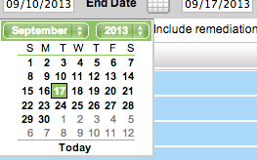
- In the Student list, select the students to whom you want to assign the test by clicking the check boxes preceding the student names. To select all students, click the check box located in the table header.
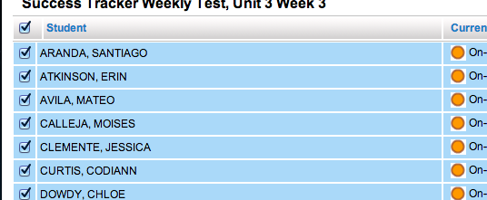

- Scroll down and Click Save.
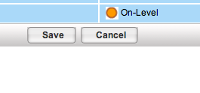
- Repeat the procedure for the next test.

