How to change a student’s SuccessNet Language-

Log in to your SuccessNet account

Go to Classes

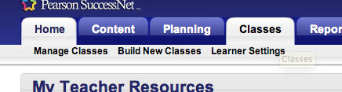

Go to Manage Classes

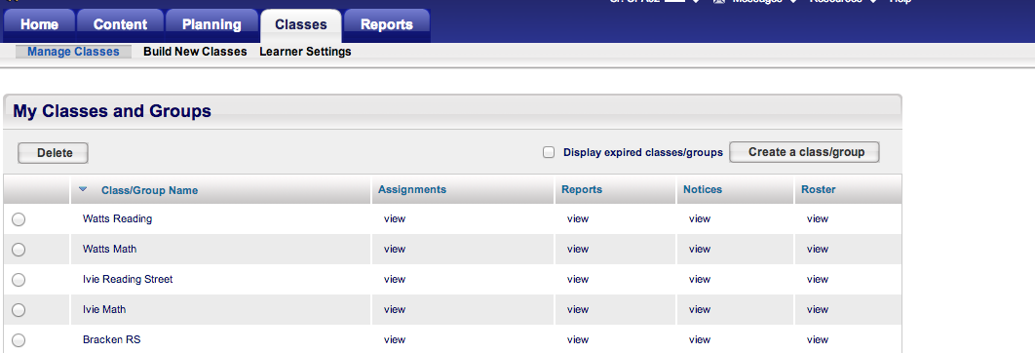

Find your class you want to edit, click on view under Roster

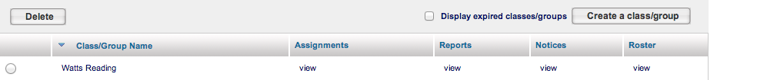

This will open your class, then select Edit roster

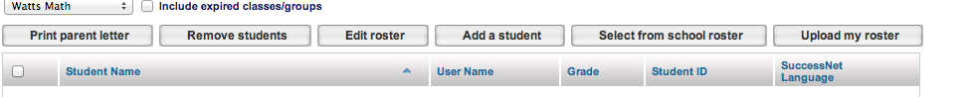

Then click on the box for the student under SuccessNet Language

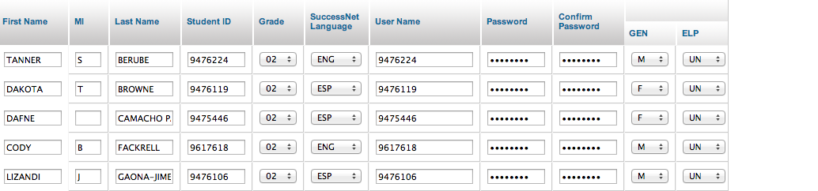

Then you can toggle back and forth between ENG( Englsih) and ESP (Spanish).
Select the one you want.

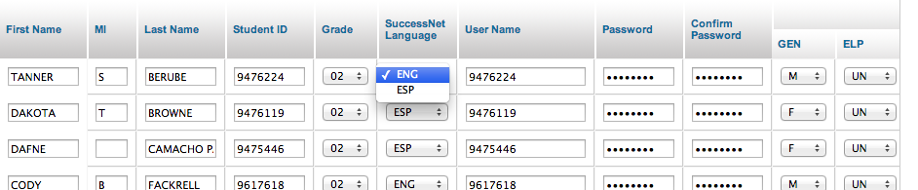

Remember to go down to the bottom of the page and hit Save!

