How to print Imagine Learning Reports

- Login to Imagine Learning
Imaginelearning.canyonsdistrict.org

- Click on Manager Login, upper right hand corner

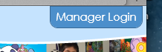

- Log in

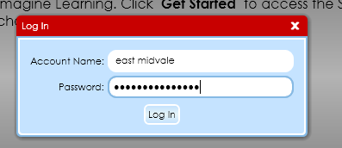

- Click on Reports

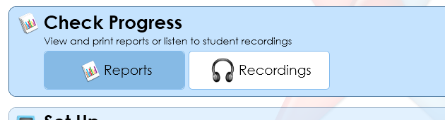

5. Click Individual Summary Report

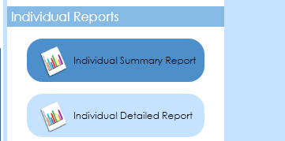

- Choose the teacher, language, and Name and Student ID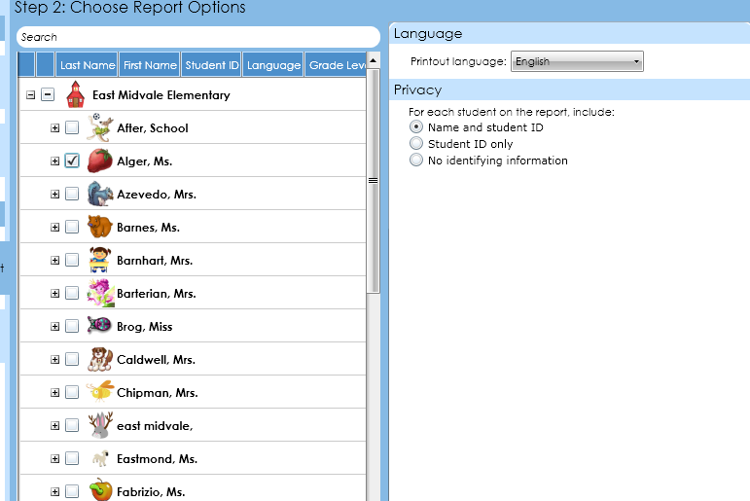

- Click View Report
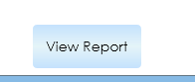

- Report will run

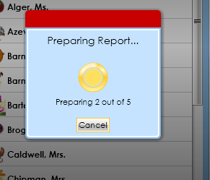

- Report will show. Most are 2 pages.

- To Print do Command P

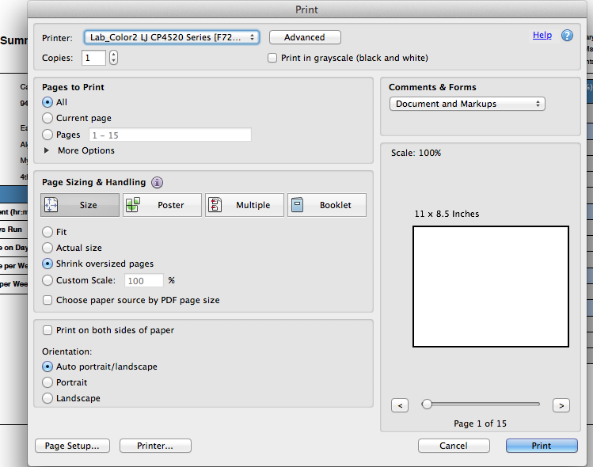

10. Press Print.

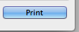

If you have questions, please ask Sierra

