How to Run SuccessMaker Student Reports
- Log in to SuccessMaker
Successmaker.canyonsdistrict.org
Your Username is FIRSTNAMELASTNAME
Your Password is LASTNAME

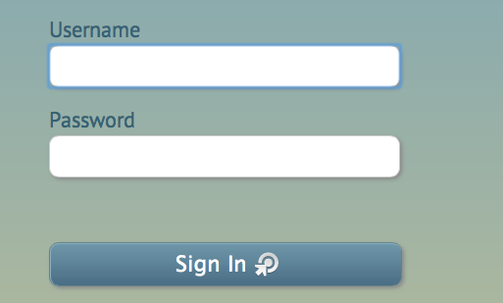

2. On the right hand of your screen, look where it says ASSIGNMENTS, click READING tab, then click RUN A REPORT

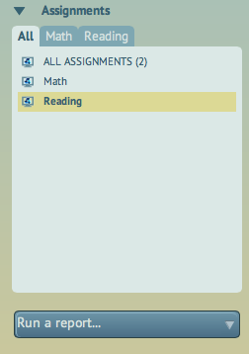
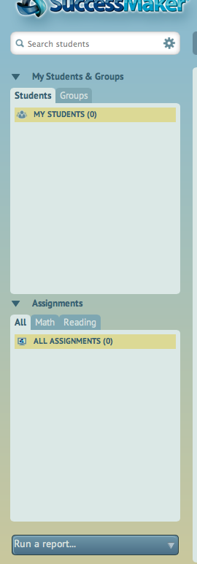

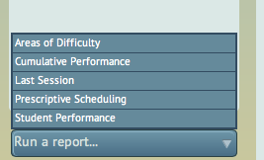
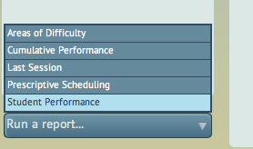
- 3. This will pop up

4. Click STUDENT PERFORMANCE

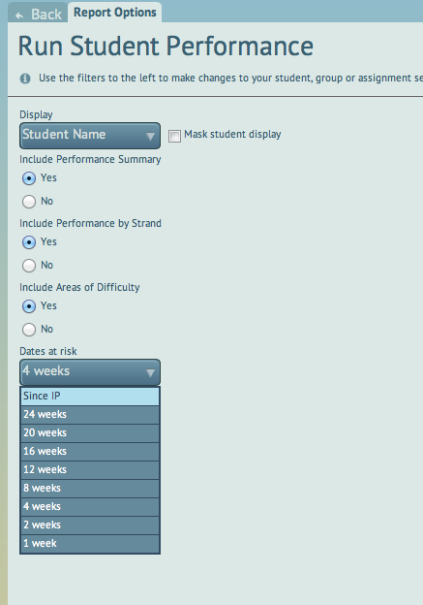

5. Change
DATES AT RISK to SINCE IP

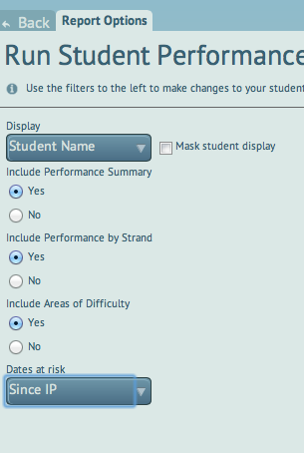

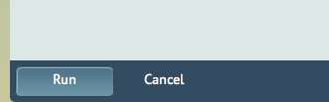

6. Click RUN

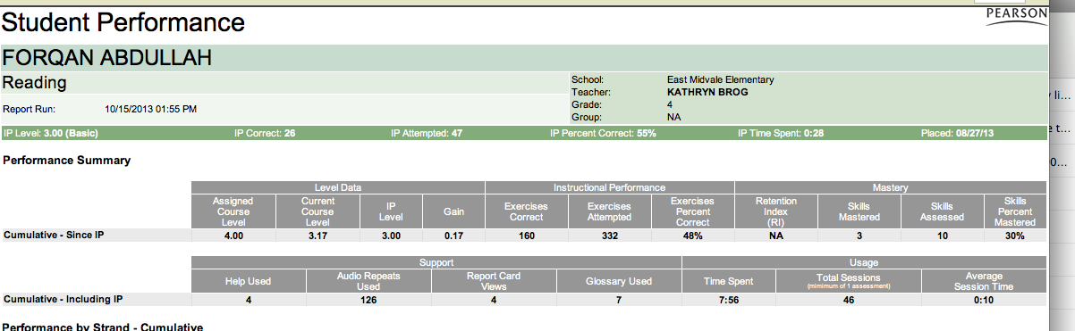
7. The Report will generate. This is the READING report.

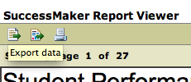
8. To print the report, click the print icon in the top left hand corner. Change the file type to a PDF

