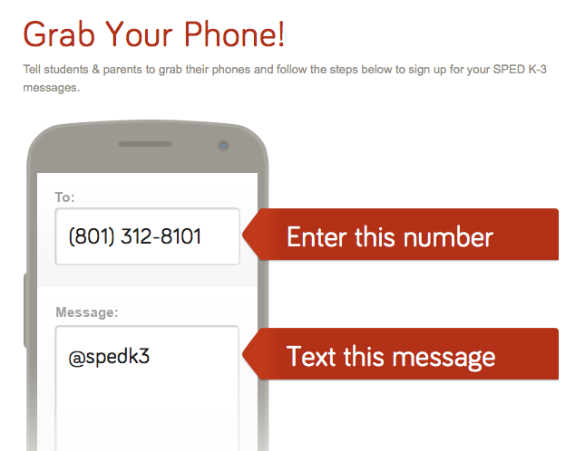

Any texts you receive from me will come from this phone number!

Thanks so much for being an active part of your student’s education!

Hello! In order to better communicate with you, I am now using Remind101! This allows me to text reminders, tell you great things about your student and give other important information quickly! In order to participate, follow the directions below: